**CO3 programs**

**1.Work with built-in packages**

**a)Module Math**

import math

print(math.pi)

print(".....................\n")

import math as m

print(m.pi)

print(".....................\n")

from math import pi,sqrt

print("Value of pi is ",pi)

print("Value of square root is ",sqrt(9))

print(".....................\n")

from math import sin,cos,tan

print("Value of sin(90) is ",sin(90))

print("Value of cos(90) is ",cos(90))

print(math.cos(90))

print("Value of tan(90) is ",tan(90))

print(".....................\n")

**Output**

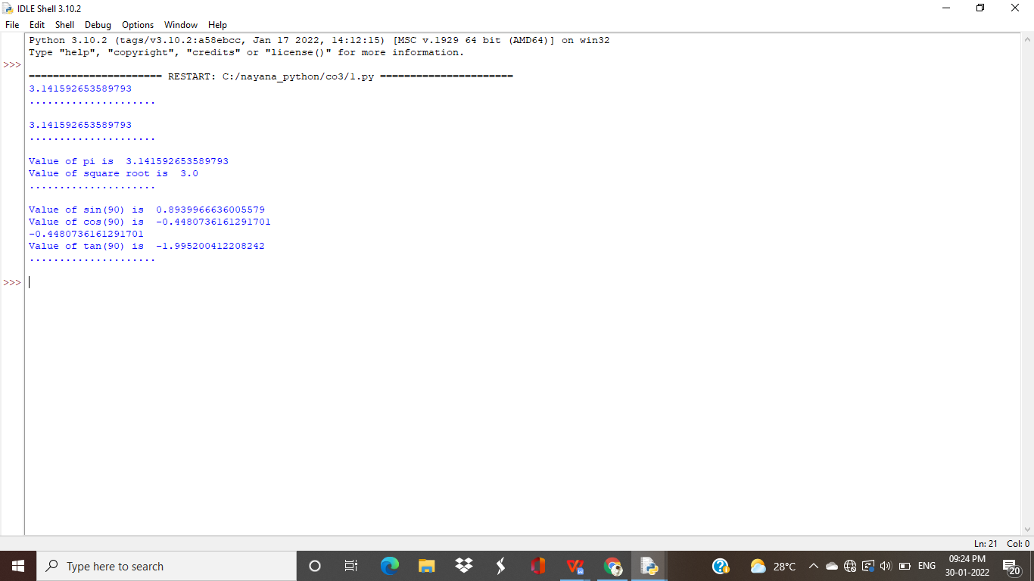

**b)Module time**

import time

print("Current time in second : ",time.time())

print("Current time : ",time.ctime())

print("Current time after 30 seconds : ",time.ctime(time.time()+30))

t=time.localtime()

print("time:",t)

print("current year:",t.tm_year)

print("current month:",t.tm_mon)

print("current day:",t.tm_mday)

print("current week day:",t.tm_wday)

print("current Hour:",t.tm_hour)

print("current Minute:",t.tm_min)

print("current Second:",t.tm_sec)

**Output**

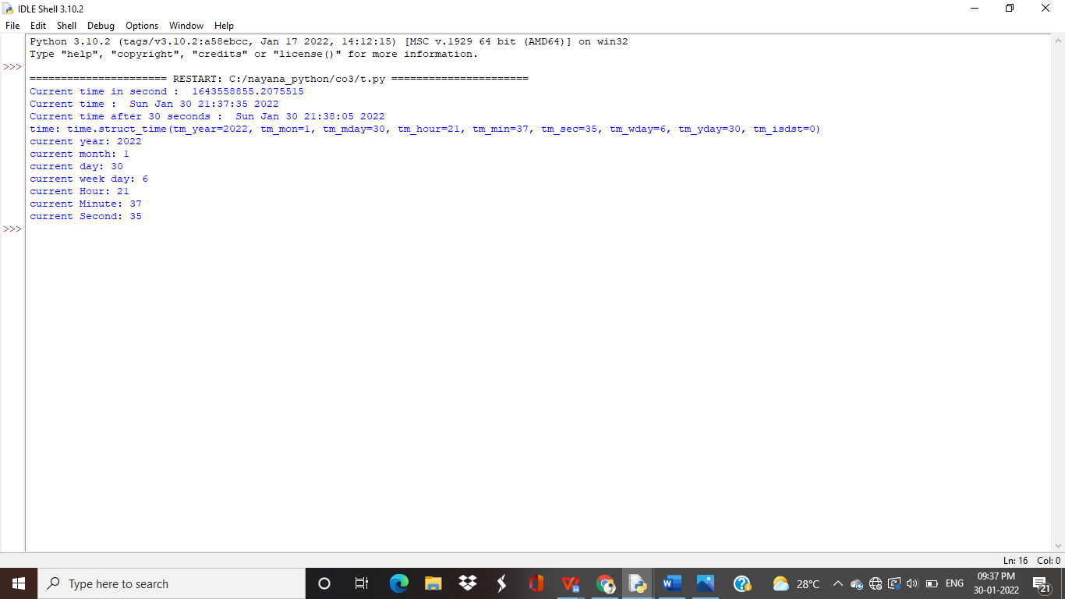

**c)Module calendar**

import calendar

mm=int(input("enter the month"))

yy=int(input("enter the year"))

print(calendar.month(yy,mm))

print(calendar.calendar(2015))

**Output**

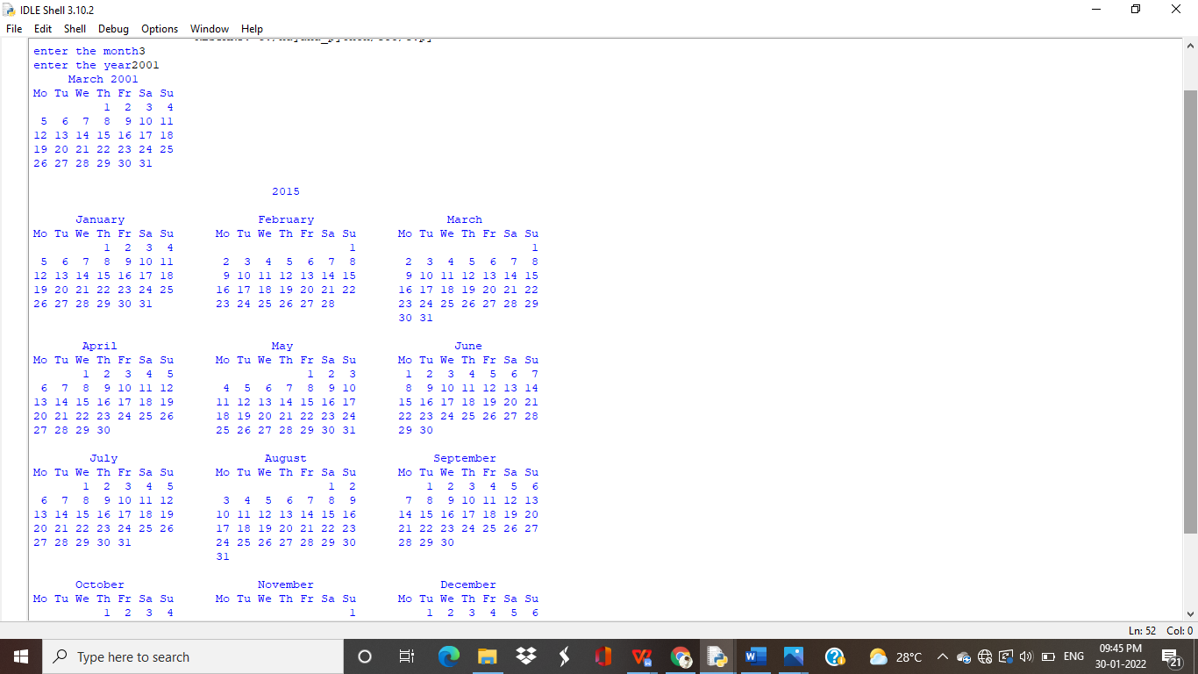

**d)Module datetime**

import datetime

t=datetime.time(22,56,44) #time class

print(t)

print("Hour :",t.hour)

print("Minute :",t.minute)

print("Second :",t.second)

print("Microsecond :",t.microsecond)

print("......................................\n")

d=datetime.date.today()

print(d)

print("Year",d.year)

print("Month",d.month)

print("Day",d.day)

print("......................................\n")

d1=datetime.date.today()

print(d1)

td=datetime.timedelta(days=2)

print(td)

d2=d1+td

print(d2)

print("......................................\n")

dt=datetime.datetime.combine(d,t)

print(dt)

**Output**

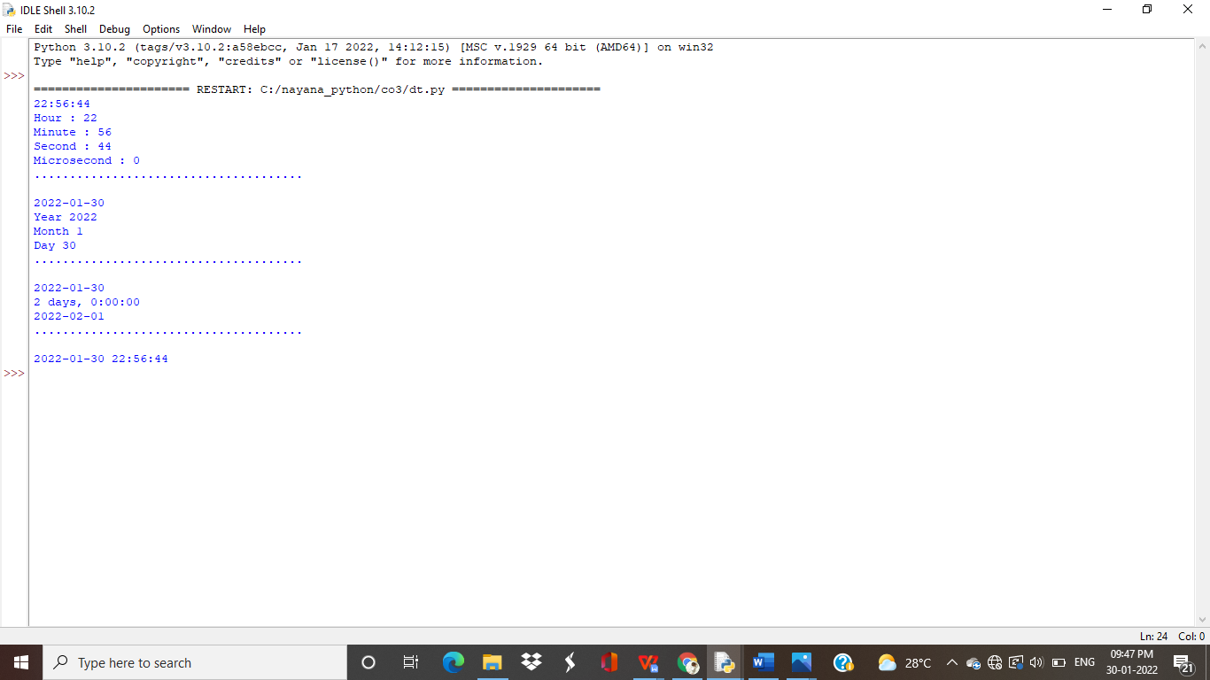

**e)Module random**

import random

mylist = ["apple", "banana", "cherry"]

print(random.choice(mylist))

print(random.choices(mylist, k=2))

print(random.sample(mylist, k=2))

random.shuffle(mylist)

print(mylist)

print(random.randrange(3, 9))

**Output**

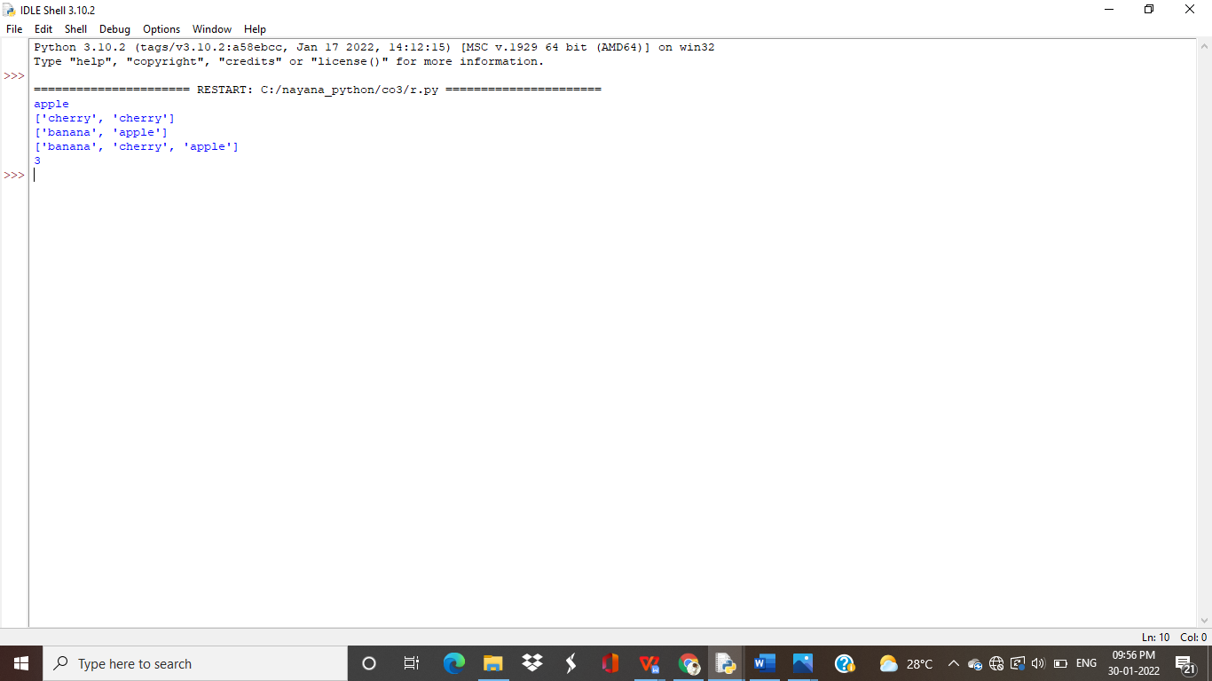

**f)Module statistics**

import statistics

print(statistics.mean([10,20,30,40,50,60]))

print(statistics.median([10,20,30]))

print(statistics.harmonic_mean([10,20,30,40,50,60]))

**Output**

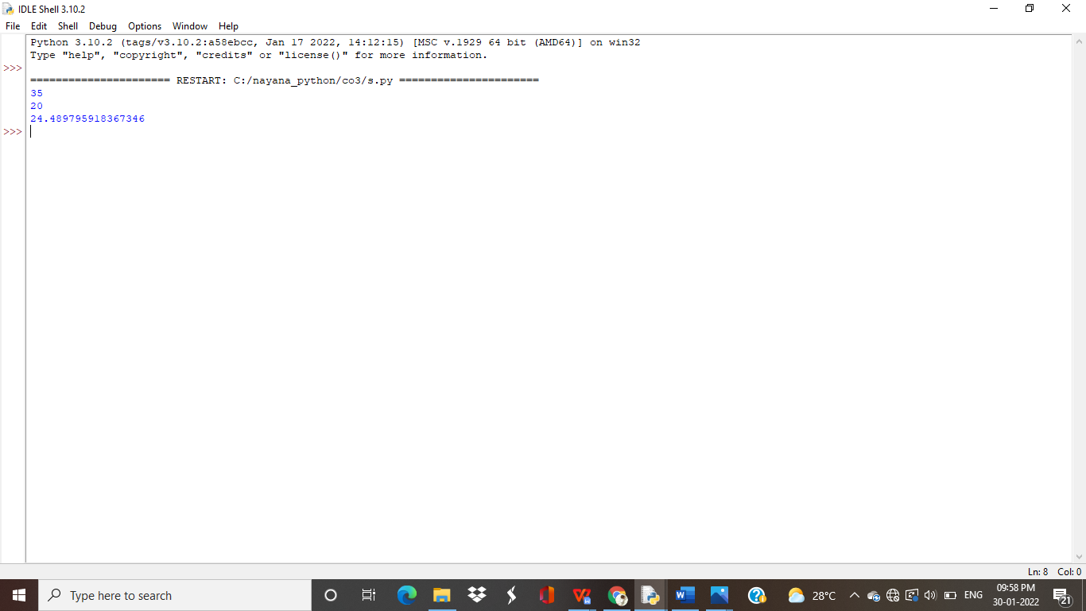

**2. Create a package graphics with modules rectangle, circle and sub-package 3D-graphics with modules cuboid and sphere. Include methods to find area and perimeter of respective figures in each module. Write programs that finds area and perimeter of figures by different importing statements. (Include selective import of modules and import * statements)**

***Package graphics***

1. **__init__.py**
2. **circle.py**

def perimeter(r):

print ("Perimeter : ",2*3.14*r)

def area(r):

print ("Area : ",3.14*r*r)

**3)rectangle.py**

def perimeter(l,b):

print ("Perimeter : ",2*(l+b))

def area(l,b):

print ("Area : ",l*b)

***Subpackage ThreeDgraphics***

1. **__init__.py**
2. **cuboid.py**

def perimeter(l,b,h):

print ("Perimeter : ",4*(l+b+h))

def area(l,b,h):

print ("Area : ",2*l*b+2*l*h+2*h*b)

**4.sphere.py**

def volume(r):

print ("Volume : ",(4/3)*3.14*r*r*r)

def area(r):

print ("Surface Area : ",4*3.14*r*r)

**graphics.py**

from graphics import rectangle

from graphics import circle

from graphics.ThreeDgraphics import cuboid

from graphics.ThreeDgraphics import sphere

l=int(input("Enter the length,l : "))

b=int(input("Enter the breadth,b : "))

rectangle.perimeter(l,b)

rectangle.area(l,b)

r=int(input("Enter the radius,r : "))

circle.perimeter(r)

circle.area(r)

l=int(input("Enter the length,l : "))

b=int(input("Enter the breadth,b : "))

h=int(input("Enter the height,h : "))

cuboid.perimeter(l,b,h)

cuboid.area(l,b,h)

r=int(input("Enter the radius,r : "))

sphere.volume(r)

sphere.area(r)

**Output**

